


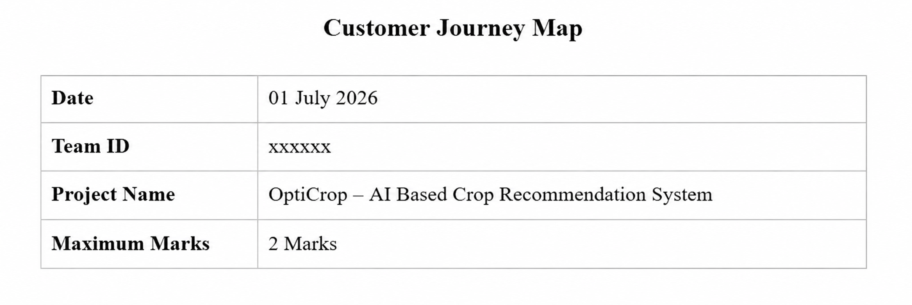
Customer Journey Map
Mapping out the customer's experience stage-by-stage, capturing their actions, touchpoints, thoughts, and feelings, along with process ownership and improvement opportunities at each stage.
Phase of  Journey | Stage 1 | Stage 2 | Stage 3
Actions | Opens the OptiCrop website.  Reads project overview.  Starts prediction. | Enters N, P, K, temperature, humidity, pH, and rainfall values.  Clicks Predict. | Views the recommended crop.  Uses the result for crop planning.
Touchpoint | OptiCrop Home Page.  Navigation Menu.  Prediction Button. | OptiCrop Home Page.  Navigation Menu.  Prediction Button. | OptiCrop Home Page.  Navigation Menu.  Prediction Button.
Customer  Thought | "Can this website help me?"  "Is it easy to use?"  "Will the prediction be accurate?" | "Have I entered the correct values?"  "How long will prediction take?"  "Will the model work correctly?" | "This recommendation matches my farm conditions."  "I can improve crop yield."  "This saves my time."
Customer  Feeling | • Curious.  • Interested.  • Confident. | • Excited  • Hopeful  • Engaged | • Satisfied  • Informed  • Confident
Process  Ownership | • User | • Flask Application & ML Model | • User
Opportunities | • Add input validation.  • Support more countries.  • Improve UI design. | • Reduce prediction time.  • Improve model accuracy.  • Handle invalid inputs. | • Display graphical charts.  • Provide detailed explanations.  • Allow report download.



